**Q#4**

**Code:**

#include<stdio.h>

#include<conio.h>

void main (void){

int rows1,columns1;

printf("Enter the number of rows and numbers of columns of the matrix\n");

scanf("%d %d",&rows1,&columns1);

int m1[rows1][columns1];

printf("Now enter the elements of the matrix:\n");

for (int i=0; i<rows1; i++){

for (int j=0; j<columns1; j++){

scanf("%d",&m1[i][j]);

}

}

printf("The matrix is:\n");

for (int i=0; i<rows1; i++){

for (int j=0; j<columns1; j++){

printf("%d\t",m1[i][j]);

}

printf("\n");

}

int rows2,columns2;

rows2=columns1, columns2=rows1;

int m2[rows2][columns2];

for (int i=0; i<rows1; i++){

for (int j=0; j<columns1; j++){

m2[i][j]=m1[j][i];

}

}

printf("The transpose of the matrix is:\n");

for (int i=0; i<columns1; i++){

for (int j=0; j<rows1; j++){

printf("%d\t",m2[i][j]);

}

printf("\n");

}

for (int i=0; i<rows2; i++){

for (int j=0; j<columns2; j++){

if ( m1[i][j] != m2[i][j] ){

printf("The Matrix is not symmetric\n");

return;

}

else{

printf("The Matrix is symmetric\n");

return;

}

}

}

}

**Output:**

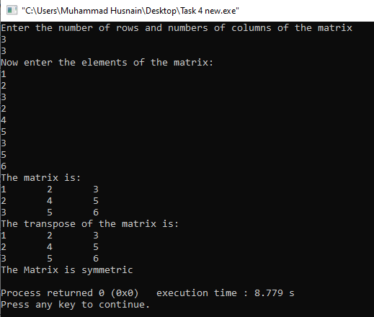

**Q#5**

**Code:**

#include<stdio.h>

void main (void){

int i,j;

for (i=1; i<=5; i++){

for (j=1; j<=9; j++){

if (j==6-i || j==4+i){

printf("*");

}

else

printf(" ");

}

printf("\n");

}

for (i=1; i<=4; i++){

for (j=1; j<=8; j++){

if (j==1+i || j==9-i){

printf("*");

}

else

printf(" ");

}

printf("\n");

}

}

**Output:**

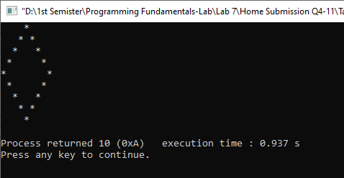

**Q#6**

**Code:**

#include<stdio.h>

#include<conio.h>

void main(void){

int size,i,j,frequency;

printf("Enter the size of the array:\n");

scanf("%d",&size);

int a[size];

printf("Enter the elements of the array:\n");

for (i=0; i<size; i++){

scanf("%d",&a[i]);

}

for (i=0; i<size; i++){

if (a[i]!=0){

frequency=1;

for(j=i+1; j<size; j++){

if (a[i]==a[j]){

frequency++;

a[j]=0;

}

}

printf("The frequency of %d is %d\n",a[i],frequency++);

}

}

}

**Output:**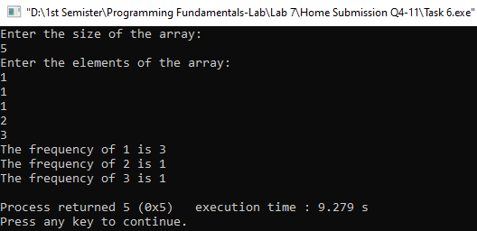

**Q#7**

**Code:**

#include<stdio.h>

#include<conio.h>

void main (void){

int rows1,columns1,rows2,columns2,sum;

rows1=columns1=rows2=columns2=sum=0;

printf("Enter the number of rows and number of columns of 1st Matrix\n");

scanf("%d %d",&rows1,&columns1);

int m1[rows1][columns1];

printf("Enter the elements of 1st Matrix\n");

for (int i=0; i<rows1; i++){

for (int j=0; j<columns1; j++){

scanf("%d",&m1[i][j]);

}

}

printf("Now enter the number of rows and number of columns of 2nd Matrix\n");

scanf("%d %d",&rows2,&columns2);

int m2[rows2][columns2];

if(columns1==rows2){

printf("Now enter the elements of 2nd Matrix\n");

for (int i=0; i<rows2; i++){

for (int j=0; j<columns2; j++){

scanf("%d",&m2[i][j]);

}

}

printf("The 1st matrix is:\n");

for (int i=0; i<rows1; i++){

for (int j=0; j<columns1; j++){

printf("%d\t",m1[i][j]);

}

printf("\n");

}

printf("The 2nd matrix is:\n");

for (int i=0; i<rows2; i++){

for (int j=0; j<columns2; j++){

printf("%d\t",m2[i][j]);

}

printf("\n");

}

int m3[rows1][columns2];

for (int i=0; i<rows1; i++){

for (int j=0; j<columns2 ;j++){

sum=0;

for (int k=0; k<rows1; k++){

sum=sum+m1[i][k]*m2[k][j];

}

m3[i][j]=sum;

}

}

printf("The Multiplication of the matrix is:\n");

for (int i=0; i<rows1; i++){

for (int j=0; j<columns2; j++){

printf("%d\t",m3[i][j]);

}

printf("\n");

}

}

else{

printf("The multiplication is not possible\n");

}

}

**Output:**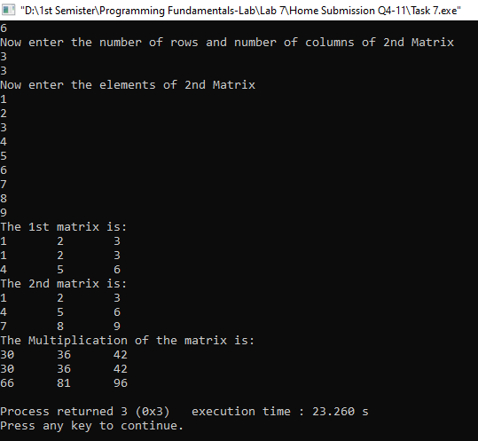

**Q#8**

**Code:**

#include<stdio.h>

#include<conio.h>

void main (void){

int size,temp;

size=temp=0;

printf("Enter the size of the array\n");

scanf("%d",&size);

int array[size];

printf("Now enter the elements of the array\n");

for (int i=0; i<size; i++){

scanf("%d",&array[i]);

}

for (int j=0; j<size; j++){

for (int i=j+1; i<size; i++){

if (array[j]>array[i]){

temp=array[j];

array[j]=array[i];

array[i]=temp;

}

}

printf("%d ",array[j]);

}

}

**Output:**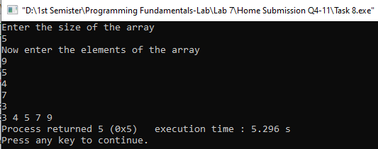

**Q#9**

**Code:**

#include <stdio.h>

#include<conio.h>

void main(void) {

int X, Y;

printf("Enter the number of branches: ");

scanf("%d", &X);

printf("Enter the number of mobile phones per branch: ");

scanf("%d", &Y);

int bill[X][Y];

for (int i = 0; i < X; i++) {

for (int j = 0; j < Y; j++) {

printf("Enter bill amount for Branch %d, Mobile Phone %d: ", i + 1, j + 1);

scanf("%d", &bill[i][j]);

}

}

int totalbranch[X],totalbill, maxbillofbranch, maxbillofphone,maxbill;

totalbill=maxbillofbranch=maxbillofphone=maxbill=0;

for (int i = 0; i < X; i++) {

totalbranch[i] = 0;

for (int j = 0; j < Y; j++) {

totalbill += bill[i][j];

totalbranch[i] += bill[i][j];

if (bill[i][j] > maxbill) {

maxbill = bill[i][j];

maxbillofbranch = i;

maxbillofphone = j;

}

}

}

printf("\nThe total bill for all branches is %d\n", totalbill);

for (int i = 0; i < X; i++) {

printf("The total bill for branch %d is %d\n", i + 1, totalbranch[i]);

}

printf("The branch with the highest bill is %d\n", maxbillofbranch + 1);

printf("The mobile phone id with maximum bill is %d\n", maxbillofphone + 1);

}

**Output:**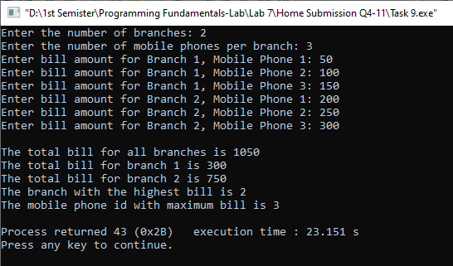

**Q#10**

**Code:**

#include <stdio.h>

#include<conio.h>

void main(void) {

int X, Y;

printf("Enter the number of branches: ");

scanf("%d", &X);

printf("Enter the number of mobile phones per branch: ");

scanf("%d", &Y);

int bill[X][Y];

for (int i = 0; i < X; i++) {

for (int j = 0; j < Y; j++) {

printf("Enter bill amount for Branch %d, Mobile Phone %d: ", i + 1, j + 1);

scanf("%d", &bill[i][j]);

}

}

int totalbranch[X],totalbill, maxbillofbranch, maxbillofphone,maxbill;

totalbill=maxbillofbranch=maxbillofphone=maxbill=0;

for (int i = 0; i < X; i++) {

totalbranch[i] = 0;

for (int j = 0; j < Y; j++) {

totalbill += bill[i][j];

totalbranch[i] += bill[i][j];

if (bill[i][j] > maxbill) {

maxbill = bill[i][j];

maxbillofbranch = i;

maxbillofphone = j;

}

}

}

printf("\nThe total bill for all branches is %d\n", totalbill);

for (int i = 0; i < X; i++) {

printf("The total bill for branch %d is %d\n", i + 1, totalbranch[i]);

}

printf("The branch with the highest bill is %d\n", maxbillofbranch + 1);

printf("The mobile phone id with maximum bill is %d\n", maxbillofphone + 1);

}

**Output:**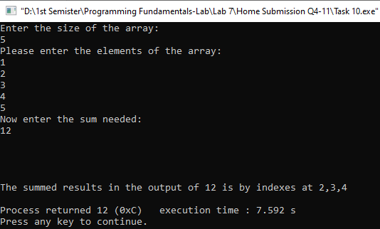

**Q#11**

**Code:**

#include<stdio.h>

#include<conio.h>

void main (void){

int inputarray[4][4], newarray1[3][3], newarray2[3][3], newarray3[3][3], newarray4[3][3];

printf("Enter the elements of the 4-by-4 matrix\n");

for (int i=0; i<4; i++){

for (int j=0; j<4; j++){

scanf("%d",&inputarray[i][j]);

}

}

printf("\nThe input 4-by-4 matrix is:\n");

for (int i=0; i<4; i++){

for (int j=0; j<4; j++){

printf("%d\t",inputarray[i][j]);

}

printf("\n");

}

for (int i=0; i<3; i++){

for (int j=0; j<3; j++){

newarray1[i][j]=inputarray[i][j];

}

}

for (int i=0; i<3; i++){

for (int j=0; j<3; j++){

newarray2[i][j]=inputarray[i][j+1];

}

}

for (int i=0; i<3; i++){

for (int j=0; j<3; j++){

newarray3[i][j]=inputarray[i+1][j];

}

}

for (int i=0; i<3; i++){

for (int j=0; j<3; j++){

newarray4[i][j]=inputarray[i+1][j+1];

}

}

printf("\nThe first 3-by-3 Matrix is:\n");

for (int i=0; i<3; i++){

for (int j=0; j<3; j++){

printf("%d\t",newarray1[i][j]);

}

printf("\n");

}

printf("\nThe second 3-by-3 Matrix is:\n");

for (int i=0; i<3; i++){

for (int j=0; j<3; j++){

printf("%d\t",newarray2[i][j]);

}

printf("\n");

}

printf("\nThe third 3-by-3 Matrix is:\n");

for (int i=0; i<3; i++){

for (int j=0; j<3; j++){

printf("%d\t",newarray3[i][j]);

}

printf("\n");

}

printf("\nThe fourth 3-by-3 Matrix is:\n");

for (int i=0; i<3; i++){

for (int j=0; j<3; j++){

printf("%d\t",newarray4[i][j]);

}

printf("\n");

}

int max1,max2,max3,max4;

max1=newarray1[0][0], max2=newarray2[0][0], max3=newarray3[0][0], max4=newarray4[0][0];

for (int i=0; i<3; i++){

for (int j=0; j<3; j++){

if (max1<newarray1[i][j]){

max1=newarray1[i][j];

}

}

}

for (int i=0; i<3; i++){

for (int j=0; j<3; j++){

if (max2<newarray2[i][j]){

max2=newarray2[i][j];

}

}

}

for (int i=0; i<3; i++){

for (int j=0; j<3; j++){

if (max3<newarray3[i][j]){

max3=newarray3[i][j];

}

}

}

for (int i=0; i<3; i++){

for (int j=0; j<3; j++){

if (max4<newarray4[i][j]){

max4=newarray4[i][j];

}

}

}

int finalarray[2][2]={{max1,max2},{max3,max4}};

printf("\nThe final output is\n");

for (int i=0; i<2; i++){

for (int j=0; j<2; j++){

printf("%d\t",finalarray[i][j]);

}

printf("\n");

}

}

**Output:**